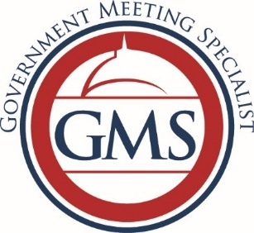
Government Meeting Specialist Tracking Sheet

Name of Member:
Company:
 | Date Completed | Date Completed | Date Completed
Education/Programming (3 programs)
Ethics (1 program)
Facilities and Services (2 programs)
Financial and Contract Management (2 programs)
Logistics (2 programs)
Personal and Professional Development (1 program)
Protocol (1 program)
Technology (2 programs)
Travel: Federal, State, and Local (1 program)
The total class time is 15 programs for initial and 20 programs for renewal

Chapter Officer Use Only

Date Received Application ___________________________________________________________

Date Certification Granted __________________________________________________________

Member since _____________________________________________________________________

*Note that the hours shown above in the tracker are for earning the initial certificate. Any combination of 20 hours may be used for renewal.

