Sunday, March 15, 2026
9:00 am – 1:00 pm | GOSGMP Board Meeting Sunrise Room
2:00 pm – 4:00 pm | Registration Landing
4:00 pm – 5:30 pm | Opening Session: “Speed Networking” - This high-impact session gives planners the opportunity to engage in quick, structured meetings with multiple suppliers in a short amount of time. It’s an efficient way to expand their network, gather valuable insights, and make informed decisions. By the end of the session, planners will have uncovered new opportunities and built connections that can lead to lasting partnerships. Riverside AB
5:45 pm – 7:15 pm | Welcome Reception Riverside C
8:00 pm | Fascination Funland Arcade (Sponsored by Seaside)

Monday, March 16, 2026
8:00 am – 9:00 am | Breakfast Riverside C
9:00 am – 10:30 am | Session: Rob Coffman – “Eat Right, Act Right, Do It Right!” Three fast-paced, mini sessions rolled into one workshop. This session is designed to provide you with a few key best practices and takeaways covering fresh food and beverage ideas, essential event protocol tips, and ethical considerations in the hospitality industry. Whether you're a seasoned planner or a rising supplier, this session delivers practical insights you can put to work immediately. Riverside AB
10:30 am – 11:00 am | Break
11:00 am – 12:30 pm | Keynote: Annie Meehan – “Choose to Soar…Navigating Disruption in Business and Life” Devastating storms have been cycling through our economy, healthcare system, businesses, and our families the past several years, disrupting everything we once thought we could count on. But the truth is, storms of this size weren’t just created overnight… Many of us have been caught up in a whirlwind for a while now. Weathering the Storms is a presentation about personal and professional resilience and the steps you and your team can take to persevere through the eye of the storm with hope, a plan, and Annie’s actionable steps on the other side. Riverside AB
12:30 pm – 1:30 pm | Lunch Riverside C
1:30 pm – 3:00 pm | Session: Michael Steinberg – “Giving & Receiving Feedback: Why It’s Important, Why It’s Hard, How to Make It Better”  Giving and receiving feedback, even when done constructively, can be inherently challenging, often raising tough emotions or making us feel insecure in work relationships. Yet, feedback from colleagues and supervisors is essential to learning and growth, both personally and professionally. In this workshop, you’ll learn specific skills and approaches that will empower you to offer and receive feedback to everyone’s greatest learning advantage. Riverside AB
6:00 pm-10:00 pm | Dinner and Silent Auction - BEACH Theme, of Course! Casual and breezy – Hawaiian shirts, sundresses, flip flops, and sun hats. Have fun dressing up as your favorite beach-themed character, whether it’s a classic surfer, lifeguard, or tourist, or someone iconic from TV or movies like Moana, Baywatch, Hawaii Five-0, or Gilligan’s Island. Riverside BC

Tuesday, March 17, 2026
8:00 am – 9:00 am | Breakfast Riverside C
9:00 am – 10:30 am | Session: Rob Coffman – “SGMP: More Than Just a Membership” Discover the story behind SGMP and why it matters to you. This session offers an overview of the Society of Government Meeting Professionals—its national history, organizational structure, and the wide range of benefits and opportunities it provides. Whether you're new to SGMP or looking to deepen your involvement, you'll learn how to make the most of your membership, expand your professional network, and tap into valuable resources that support your success in the government meetings industry. Riverside AB
10:30 am – 11:00 am | Break – Check out
11:00 am – 12:30 pm | Keynote: Annie Meehan – “How to Be a Pineapple Person in a Prickly World” A fun and heartfelt keynote on staying sweet in a sometimes sour world. Annie inspires audiences to stand tall, stay kind, and lead with heart—even under pressure. Blending humor, real-life stories, and practical tools, she shows how to build Hopeful, Healthy, and Human workplaces where people feel valued and engaged.  Takeaways: Boost resilience, reduce burnout, strengthen collaboration, and spark people-first leadership that helps teams thrive. Riverside AB
12:30 pm – 1:30pm | Lunch and Closing Riverside C

Thank you to our sponsors for their generous donation and support!

Gold Sponsors
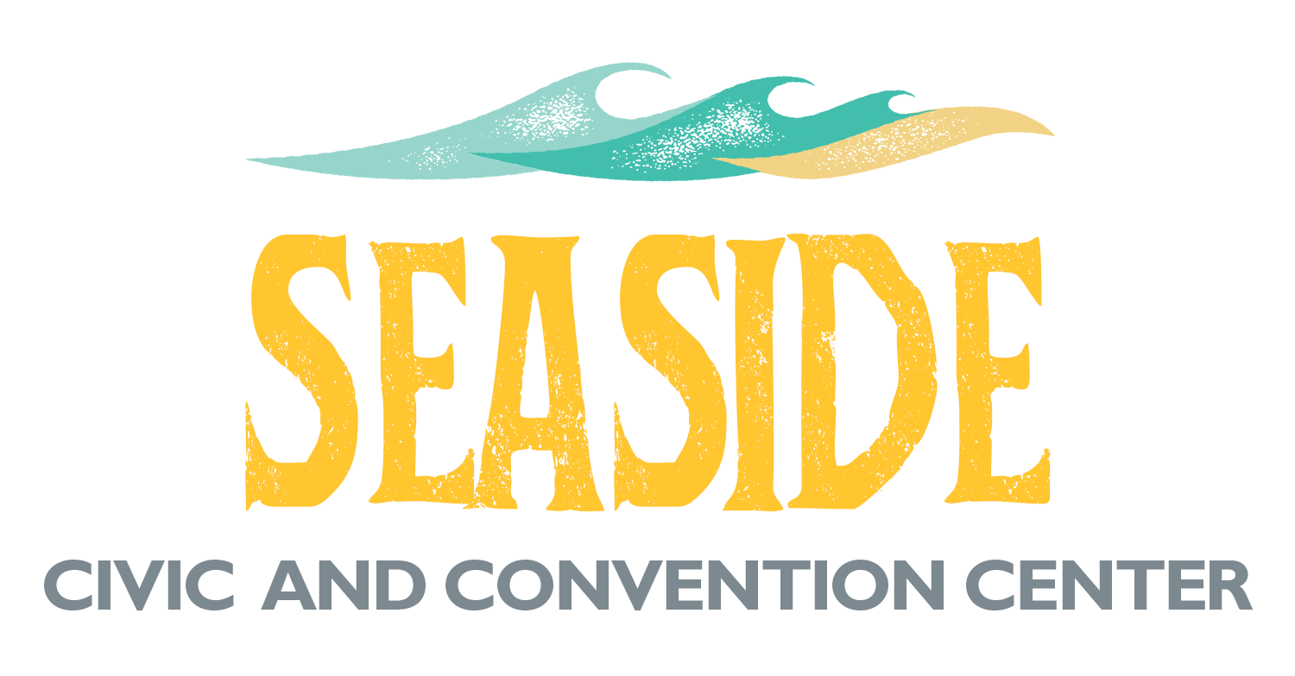





Silver Sponsors



